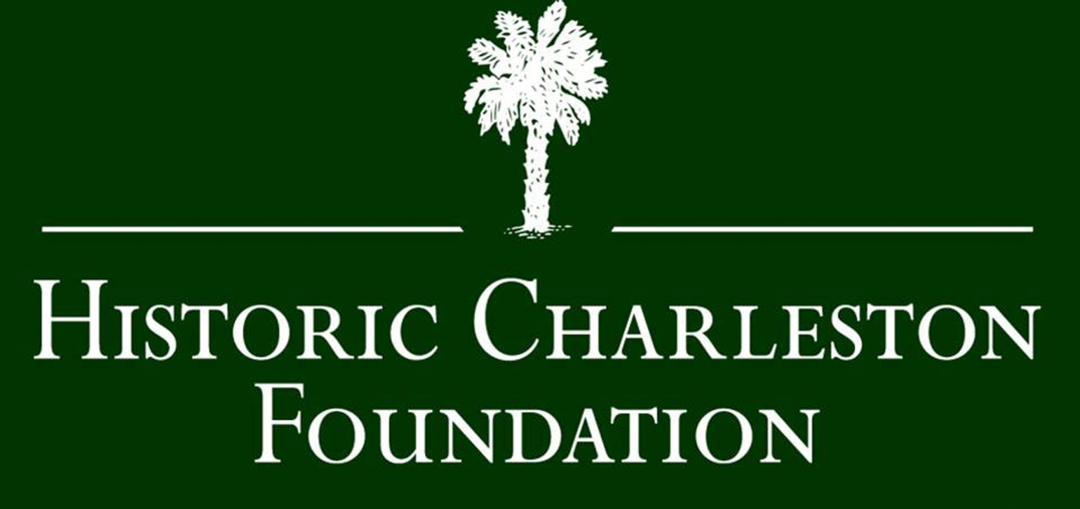

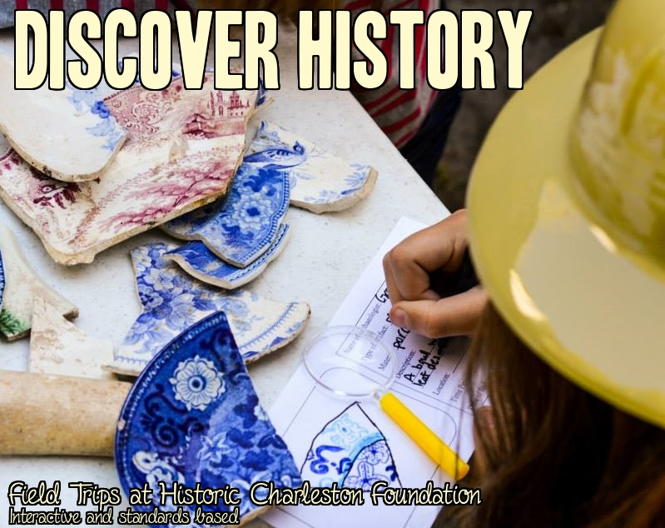

Program Description: Make social studies come alive with one of the programs offered by the Education team at Historic Charleston Foundation. Come visit our historic house museums on a field trip, rent a traveling trunk full of artifacts and lesson plans, or invite one of our staff members to come to your classroom as a historian-in-residence to teach fun and engaging classes to your students.

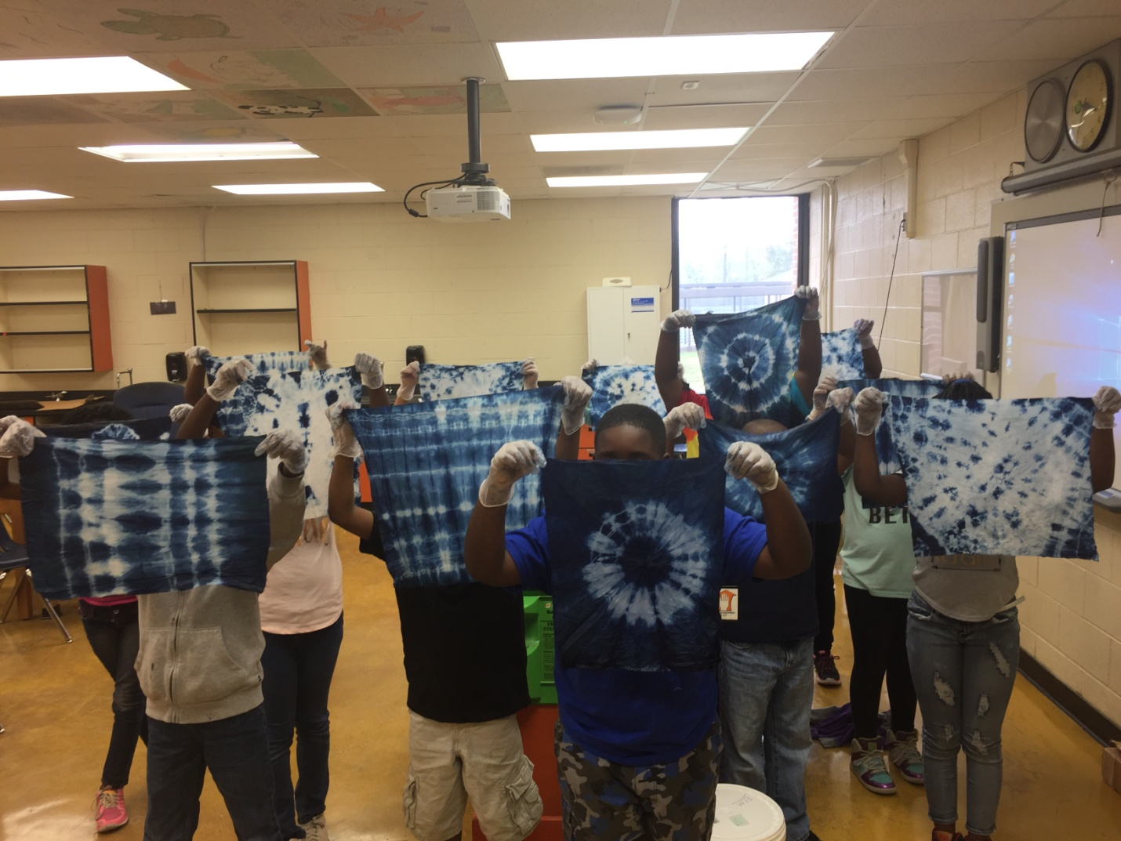
In-Class Experiences:
Historic Charleston Foundation offers many different programs that can be taught in your classroom by a member of our Education Team. Having trouble making any of the Social Studies standards fun and engaging? We are here to help with hands on activities, lessons, and crafts.

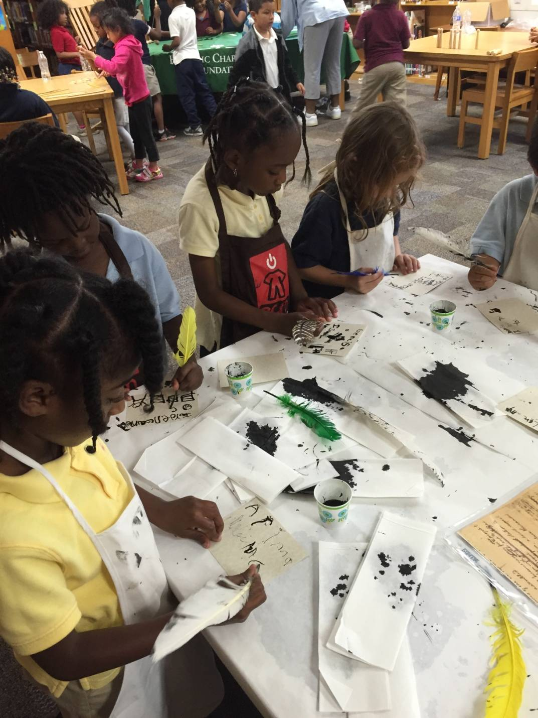
Historian-in-Residence: Bring in a historian educator to lead one class activity or for a whole week with themes relating to the American Revolution, Gullah culture, archaeology, pirates, Civil War, slavery, cash crops, and more. Our classes are very hands on and teach the standards while incorporating theatre, visual arts, and games. Have a standard that you need help with that is not on our list? Ask us about it and we can teach it! Click here for a class list.

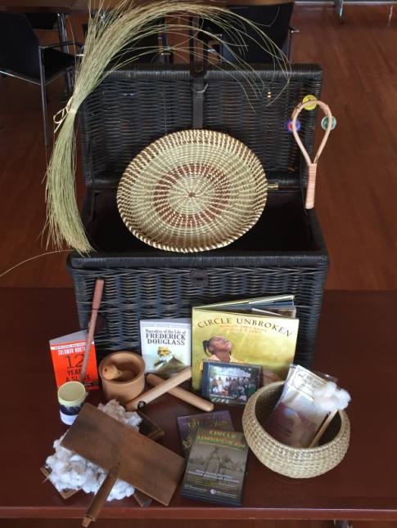
Traveling Trunks: Rent out one of HCF’s traveling trunks to use in your classroom for an entire week or longer to help students connect to your social studies lesson plans. Each trunk is filled with artifacts, lesson ideas, books, multimedia, games, and activities for you to use in conjunction with your social studies classes. We have trunks available for grades K-8 and you can reserve a trunk and combine it with a field trip or Historian-in-Residence class for a complete experience. To learn more about what trunks we have click here.

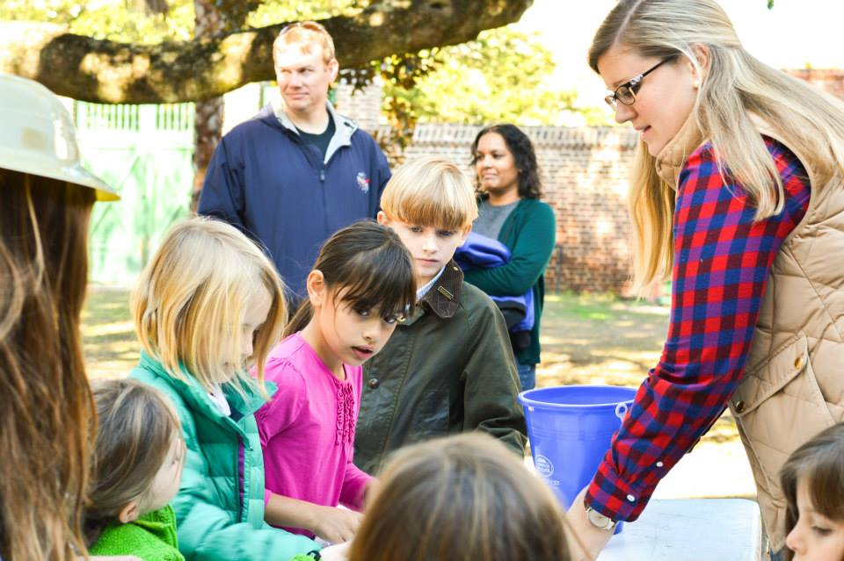
Field Trips:
Below are the most popular field trips for school groups. Students will get to explore historic house museums and the downtown historic district.

Antebellum South Carolina: In this field trip, students will visit both the Nathaniel Russell House (c. 1808) and Aiken-Rhett House (c. 1820) to get a complete picture of what Antebellum South Carolina was like up through the Civil War. Learn about daily life, economic classes, slavery, politics, and more! This program is designed for 3rd grade and 8th grade social studies standards, but suitable for any classes studying South Carolina or early American history. Field trip includes on hands on activities and a scavenger hunt. Click to view the teacher packet.

Children and Families of the Past: In this field trip, students will visit both the Nathaniel Russell House (c. 1808) and Aiken-Rhett House (c. 1820) to get understand what it was like to be a kid in the past. Learn about daily life, technology, transportation, entertainment, and more! This program is designed for K-2nd grade social studies standards and students will get to play games from the past and complete a scavenger hunt. Click to view the teacher packet.

King Charles to King Cotton South Carolina 1670-1860
Field Trip Experience: Historic Charleston Foundation’s Nathaniel Russell House has teamed up with The Powder Magazine and Old Slave Mart Museum to offer an educational field trip program that explores 200 years of Charleston history right where it happened. This field trip is designed for South Carolina Public Schools, is curriculum based, and includes hands on activities and a scavenger hunt that connects the three sites. Click to view the teacher packet.


