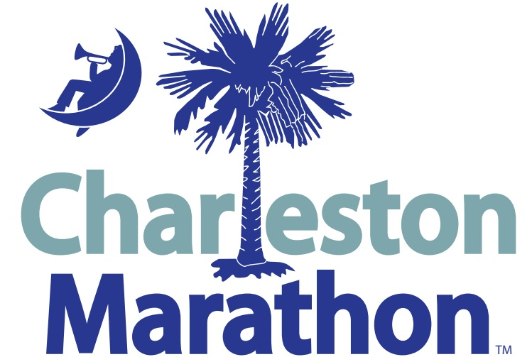

Grants Program for Schools

APPLICATION PURPOSE
Engaging Creative Minds (ECM) was founded in 2012 by leaders from local school districts, the College of Charleston, the Cities of Charleston and North Charleston, the Charleston Regional Alliance for the Arts, the Youth Endowment for the Arts, and the Crystal-Barkley Corporation. The mission of Engaging Creative Minds is to inspire the creative and innovative potential of all students to achieve academically and become imaginative, adaptable, and productive adults resulting in stronger communities and an increasingly competitive South Carolina workforce. The O2 Fitness Charleston Marathon is ECM’s annual fundraiser. 20% of the net proceeds from the O2 Fitness Charleston Marathon go to school grants. The ECM/O2 Fitness Charleston Marathon Grants Program projects must give credit in all printed materials as follows:
“This project was funded with proceeds from the O2 Fitness Charleston Marathon, the annual fundraiser for Engaging Creative Minds.”
The ECM/O2 Fitness Charleston Marathon Grants Program (formerly the YEA Grants Program) supports students in Charleston County, Berkeley County, and Dorchester District 2 through grants from $100 - $2,000 to fund the following initiatives: art integrated projects in all art disciplines that increase academic achievement and participation in the arts; and arts equipment for which funding sources are limited.
All grant checks are written to schools.

APPLICATION PROCESS
Application/Report available at charlestonmarathon.com
Recipients from 2017 Report Deadline: 2018 Application Deadline: Notifications mailed:
04/20/18 04/20/18 05/18/18

A completed application must be submitted to your school administrator (see below) by the deadline, April 20, 2018, in order to be considered for funding for the 2018-2019 school year. Applicants must use the current application form. Completed applications will be collected and verified by the coresponding district Fine Arts Office. Applications will then be given to the Engaging Creative Minds Marathon Committee for a blind review and scoring process. Proposals with the highest overall score (including bonus points earned for the O2 Fitness Charleston Marathon participation) will be awarded until funding is exhausted.
Applicants may receive only one annual grant per academic school year.

Email submission to:
Charleston County School District: Catherine Hines-McCormack, catherine_hines@charleston.k12.sc.us
Berkeley County School District: Ryan Westberry, westberryr@bcsdschools.net
Dorchester School District 2: Scott Rush, srush@dorchester2.k12.sc.us

For more information please contact:
Susan Antonelli, Director of Education, Engaging Creative Minds 843-277-2016 or email at susan@engagingcreativeminds.org

Engaging Creative Minds/O2 Fitness Charleston Marathon Grants Program For Schools
APPLICATION FOR SCHOOLS
Serving students in Charleston, Berkeley, and Dorchester District 2 Public Schools

APPLICATION COVER SHEET

Name of School: ______________________________________________

School District: ___________________________________________________________________________

Grade Level(s) this grant will serve:________________________ Telephone #_________________________

Contact Name and Title:

Mailing Address:

Email______________________________________ Website______________________________________

Name of Project:____________________________Date/s_______________Location/s_________________________

Total Grant Amount Requested: _______________________________

Record of in-kind services provided during the 2018 O2 Fitness Charleston Marathon:

(Please answer each line item below with yes or no)

Delivered an art piece _________Yes ___________No
If applicable, how many art pieces did you deliver? _________
Provided a performing group during the marathon _________Yes __________No
My school sponsored an Aid/Water Station during the Marathon _________Yes _________No
My school sent additional volunteers to work in another capacity (not listed above, such as volunteering at the Marathon Expo, serving as course marshals, working the start/finish line, etc.)
_________Yes __________No Total number of additional volunteers ________

If your school has previously received grant funding from the 2017 Charleston Marathon, a follow-up report must be submitted with this application. Reports should give a brief summary of activities conducted with grant funds and provide a simple budget statement that demonstrates how Marathon grant funds were expended.

Did you receive a Charleston Marathon Grant in 2017? _________Yes __________No
If yes, what was the title of your project?_______________________________
Amount of funding received from the 2017 Charleston Marathon: _____________________
Did you attach a final report with this application? _________Yes __________No _________N/A

Marathon Committee Eligibility Requirements

Please answer the following questions in narrative format within this document.
DO NOT INCLUDE IDENTIFYING INFORMATION, such as name of school, teacher names, etc.
Limit narrative to 4 pages including all budget information and certification signatures.

- Project description: What is it specifically that you want to do? (Include information which will help the committee to understand what you propose to do.) (10 points)
If this is an Artist-in-Residence request, please describe the artist(s) or organization(s) involved with the project: (Submit resume(s) if applicable)

- List academic or artistic learning standard(s) that will be addressed through this project and indicate how they will be addressed. Expected impact on other areas of student learning is also welcome (such as social-emotional learning). (5 points)

- How will you evaluate the impact or success of your project? (Submit a sample evaluation form or tool if possible.) (5 points)

- Project Impact: How many individuals will benefit directly from the project and the proposed grant? (5 points)
Students:______________+ Personnel:______________ = Total
Does this project serve an underserved population or students with disabilities? If so, please identify the population served:

If so, what percentage of that population is served by the project?

Others (such as entire community), please describe:

- Project Budget: Please complete the table below listing supplies, fees, and purchases that will be made with grant funds. The bottom of the table should reflect the total amount requested. Then, write a brief budget justification as described below. (5 points)

Project Budget Summary
List Items to be Purchased: | List Amount:
TOTAL EXPENSES:

Budget justification: Please justify (in a brief narrative) why the items needed above are required for the successful implementation of your grant proposal. *Please note if matching or supplementary funds provided by other sources (such as the school PTA) will also be used for the full implementation of this project.

Sign, date, and return one copy of application and W9 form for the school by: April 20, 2018
(Retain one copy for your records.)

LINK TO DOWNLOAD CURRENT W-9 FORM: http://www.irs.gov/pub/irs-pdf/fw9.pdf

Certification: We certify to Engaging Creative Minds that:
The applicant is in compliance with the Marathon Committee’s eligibility requirements and ALL information contained in this application is true and correct to the best of my knowledge. The filing of this application and signatures below have been authorized by the governing body of the applicant. The activities and services for which funding is sought will be administered by or under the supervision of the applicant solely for the described funding and program in the grant application. The applicant and any organization that it assists will comply with all applicable Federal and State laws when conducting any program activity for which the applicant receives financial assistance from the O2 Fitness Charleston Marathon.

Contact Signature and Date ____________________________________________________________

Principal Signature and Date____________________________________________________________

APPLICATION FINAL CHECKLIST:

- Applicant must use current application form.
- Applicant has submitted a complete application with information filled into the spaces below each question. Do not put “see attached.” Do not leave questions unanswered.
- Applicant has provided reporting for funds received from 2017 Charleston Marathon, if applicable.
- Applicant has verified with principal one submission per school.
- Total grant application is no longer than 5 pages (including cover sheet).
- The application includes a school W9 form.

